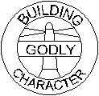_________________

**Kindergarten**

**Term 4 Report**

**Name** _______________________________________________________________________________

**Date** _______________________________

**Code:**

A = Above average

S = Satisfactory

D = Still developing this skill

**Social and Emotional Development**

|  |  |
| --- | --- |
| Enjoys playing with other children |  |
| Confident in choosing activities |  |
| Can resolve conflicts responsibly |  |
| Perseveres with tasks that are difficult |  |
| Uses good manners |  |
| Participates willingly in cleaning up |  |

**Comments:**

____________________________________________________________________________________________________

**Physical Development**

|  |  |
| --- | --- |
| Can use scissors for cutting paper |  |
| Can do up buttons |  |
| Can tie a bow, e.g. a shoe lace |  |
| Can throw and catch a large ball |  |
| Can throw and catch a small ball |  |
| Can skip with a rope |  |
| Shows good balance and strength when involved in physical activities |  |

**Comments:**

____________________________________________________________________________________________________

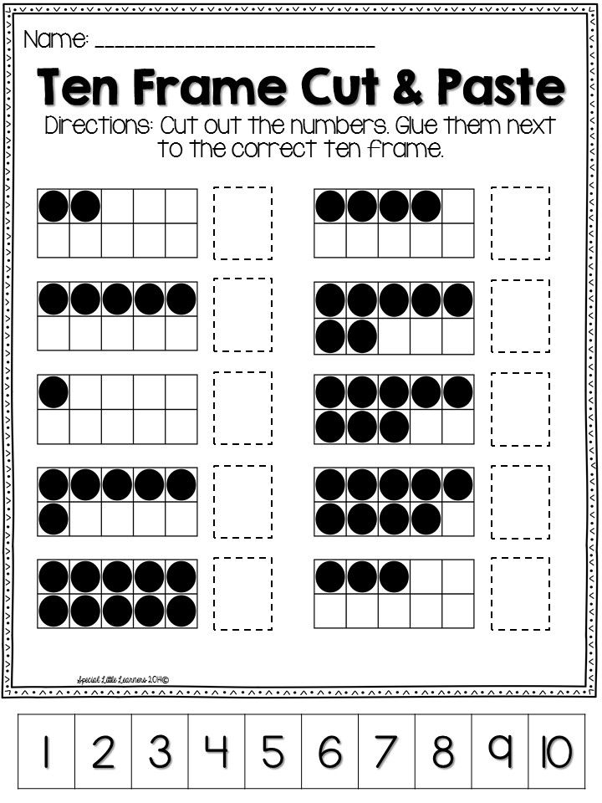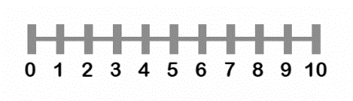**Mathematics**

Tens frame

Number line

|  |  |
| --- | --- |
| Can count to 20 (forwards and backwards) |  |
| Can makes sets with counters, e.g. 3 sets of 2 |  |
| Can solve addition tasks, e.g. 3 + 2 = |  |
| Can solve subtraction tasks, e.g., 9 – 5 = |  |
| Can solve addition and subtraction tasks using the tens frame |  |
| Can solve addition and subtraction tasks using the number line |  |
| Can write number symbols to 20 |  |
| Can recognize coins up to $2 |  |

**Comments:**

____________________________________________________________________________________________________

**Literacy**

|  |  |
| --- | --- |
| **Listening and speaking** |  |
| Listens attentively to a speaker |  |
| Participates in listening games |  |
| Participates in ‘show and tell’ |  |
| Forms complete sentences when talking about their picture |  |
| **Phonics** |  |
| Can say the starting sound of an object when shown the picture. |  |
| Can identify the letters of the alphabet using sound names. |  |
| Can match letter symbols with pictures starting with that sound |  |
| Can write the letters of the alphabet |  |
| Can sound out 3-letter words using sound names, e.g. c-a-t |  |
| **Reading** |  |
| Enjoys listening to stories and gives full attention |  |
| Enjoys looking at books alone |  |
| Can memorize words of songs and Bible verses |  |
| Can write their name |  |
| Recognizes some basic sight words and can read a simple Level 1 story |  |
| **Handwriting and drawing** |  |
| alphabet pattern worksheets alphabetworksheetsfreecom - pattern ...Can copy a pattern starting left to right, e.g. |  |
| Can write letters o the alphabet |  |
| **Expressive writing** |  |
| Can make up a sentence ‘in their head’ about their drawing, and say it aloud |  |

**Comments:**_____________________________________________________________________________________________