_______________________________

**Year 1**

**Term 2 Report**

Name ………………………………………………………………………………..

Teacher ……………………………………………………………………………...

Date ……………………………………………………………………………………



**Mathematics Year 1**

**Term 2**

|  |  |
| --- | --- |
| Can count by 2s to 20 |  |
| Can count backwards from 20 - 0 |  |
| Can put 3 given numbers (0 – 20) in order from lowest to highest |  |
| Can put 3 given numbers (0 – 20) in order from highest to lowest |  |
| Can write numbers 0 - 20 |  |
| Can fill in missing numbers (0 – 20) on a number line |  |
| Can solve problems using “more than” and “less than” on a number line |  |
| Can solve addition problems using numbers to 20, with counters |  |
| Can solve subtraction problems using numbers to 20, with counters |  |
| Can solve multiplication problems by making or drawing sets, e.g. 6 sets of 3 |  |
| Can solve addition and subtraction problems using a number line to 20 |  |
| Can find the missing number in an equation. 8 + □ = 15 |  |

Making sets to solve multiplication

number line

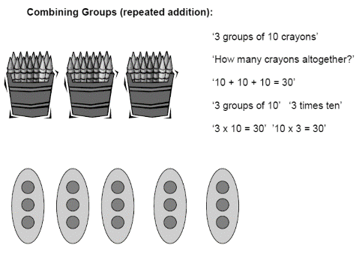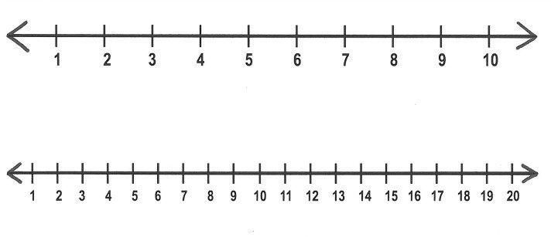

**Comments:**

____________________________________________________________________________________________________________________________________________________________________________________________________________________________________________________________________________________________________________

**Code:**

A = Above average

S = Satisfactory

D = Still developing this skill

**Literacy Year 1**

**Term 2**

|  |  |
| --- | --- |
| **Listening and speaking** |  |
| Listens attentively to a speaker |  |
| Participates in show and tell |  |
| Has a good command of spoken English |  |
| **Phonics** |  |
| Knows all the sounds of the alphabet |  |
| Can sound out 3-letter words such as c-a-t |  |
| **Reading** |  |
| Can recognize and read at least 20 sight words |  |
| Reads simple stories and gets meaning cues from the pictures |  |
| Reads simple stories making use of known sight words |  |
| Makes use of phonics when reading simple stories |  |
| **Handwriting** |  |
| Copies handwriting exercises accurately |  |
| Writes neatly, with word spacing and appropriately sized letters |  |
| **Expressive writing** |  |
| Can verbally make up a sentence using own original ideas |  |
| Confident in making up a sentence and writing it |  |

**Fijian language**

|  |  |
| --- | --- |
| Participates in songs, dances and rhythmic activities |  |

**Comments:**

____________________________________________________________________________________________________________________________________________________________________________________________________________________________________________________________________________________________________________

**Code:**

A = Above average

S = Satisfactory

D = Still developing this skill

**Thematic Studies Year 1**

**Term 2**

Science, Social Studies, Health, Christian Education, Art, Creative Thinking Skills

**Topics this term:**

**God is our Saviour:** My country Fiji

**God is Pure & Holy:** Hygiene & safety

**God is Creator:** Living & non-living

|  |  |
| --- | --- |
| Listens attentively for information |  |
| Contributes to class discussions |  |
| Shows interest in the topic |  |
| Works well in a group |  |
| Focuses on the task to be done |  |
| Contributes ideas in creative thinking exercises |  |
| Shows confidence in drawing and other art skill |  |
| Cares for books, equipment and resources |  |
| Shows responsibility in packing and cleaning up after art activities |  |
| Follows instructions |  |
| Works independently on tasks |  |
| Shows inquiry by asking appropriate questions |  |
| Presents neat and attractive work on a topic |  |
| Applies Christian values in social interaction |  |

**Comments:**

____________________________________________________________________________________________________________________________________________________________________________________________________________________________________________________________________________________________________________

**Code:**

A = Above average

S = Satisfactory

D = Still developing this skill

**Physical Education Year 1**

**Term 2**

|  |  |
| --- | --- |
| Swimming |  |
| Athletics |  |
| Games |  |
| Ball handling skills |  |

**Comments:**

______________________________________________________________________________________________________________________________________________________

**Music Year 1**

**Term 2**

|  |  |
| --- | --- |
| Can keep the beat to given music |  |
| Can clap a rhythm pattern |  |
| Participates music games |  |
| Participates in class singing |  |
| Memorizes words to songs |  |
| Performs dance movements rhythmically and accurately |  |

**Comments:**

______________________________________________________________________________________________________________________________________________________

**Code:**

A = Above average

S = Satisfactory

D = Still developing this skill