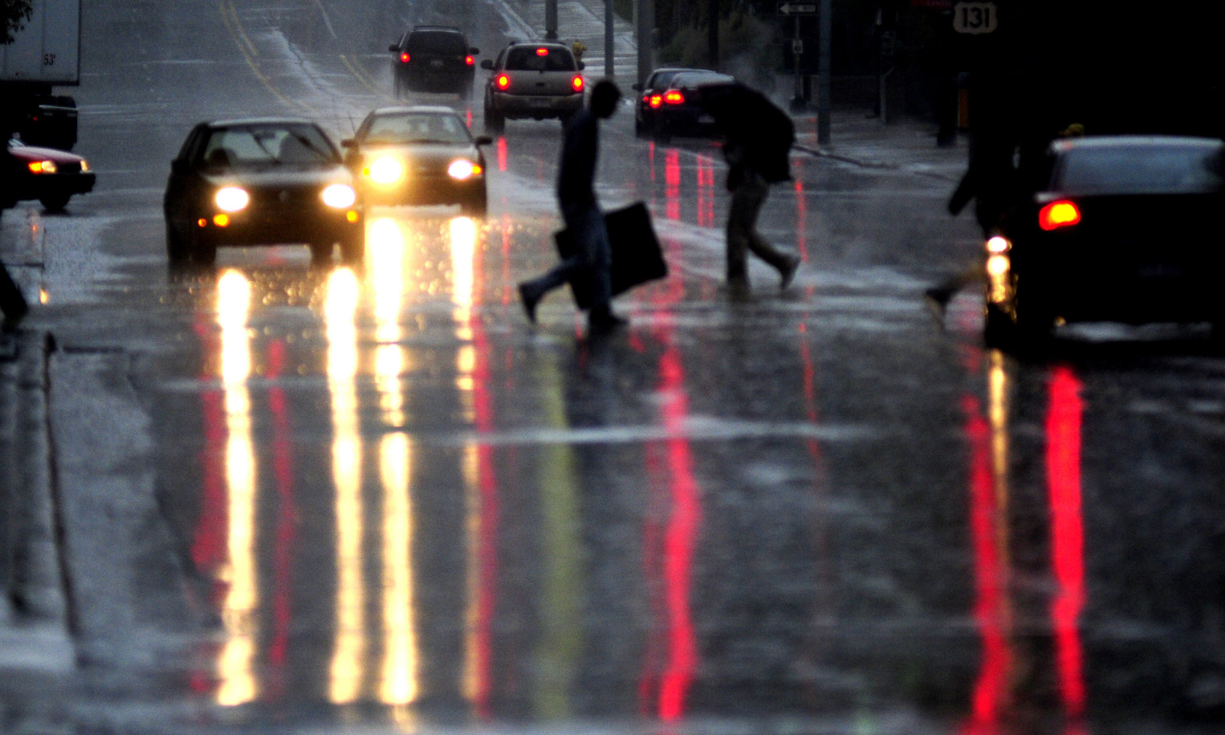
97. Students with Squints

Driving along a remote country road, in an awful storm, I am dependent on my headlights. The storm has blown all manner of detritus across the partially flooded road. If my headlights should skew off to the left on their own accord, or align themselves somewhat to the right, I would be in peril. Or should they diverge in a squint I would be at risk. I don't need the distracting details of the periphery. Jesus said that our eyes are the illuminator of our bodies, (Mt 6:22). He understood their propensity to roam from the kingdom pathway, and seek truth in other places for the lure of idols and competing spiritual leaders is strong in all ages. Nowadays it’s lauded as being tolerant and not discriminating to be multifaith in orientation. Eve let her eyes get fixed on the fruit of the knowledge of good and evil, (Gen 3:6). History would be different if she had managed to swerve them away. Our eyes are drawn to the baubles of Vanity Fair to our left, and the lure of rest and diversion on the right. Our peace and direction, and ultimately our safety, are threatened when we let our eye act in as though it was neutral and can impartially process all stimuli. We need a discriminating eye so that unwholesome and ultimately illicit things don't capture our attention and draw attention from the way. Paul wrote that “everyone who competes exercises control in all things”, (1 Cor 9:25). The athlete puts aside comforts, pleasures and vice in order to press on to sporting victory and glory. Jesus said his critics and enemies were spiritually blind. Spiritual blindness finds its terminus in the abyss of darkness, (Jude 6 and 13).
Maybe there is a lost second letter from James which forms a parallel the famous teaching on “Who can tame the tongue?” (Jas 3:8) which warns of the roaming untamed eye. As educators who co labour with Jesus we work in order that our students “open their eyes, and turn them from darkness to light and from the power of Satan unto God”, (Acts 6:18)

The eye is the lamp of the body. If your eyes are good, your whole body will be full of light. But if your eyes are bad, your whole body will be full of darkness. If then the light within you is darkness, how great is that darkness! (Matthew 6:22-23)
When the woman saw that the fruit of the tree was good for food and pleasing to the eye, and also desirable for gaining wisdom, she took some and ate it. (Gen 3:6)
And the angels who did not keep their positions of authority but abandoned their proper dwelling—these he has kept in darkness, bound with everlasting chains for judgment on the great Day. Jude 6
They are wild waves of the sea, foaming up their shame; wandering stars, for whom blackest darkness has been reserved forever. (Jude 13)
“I am the light of the world”. (Jn 8:12)

